
The Manger Christmas Menu 2023
(Available throughout December excluding Sundays, pre orders only)
(2 courses £25.95 / 3 courses £30.95)
To Start
Breaded Camembert, redcurrant and cranberry sauce (v)
Roasted Parsnip and Sherry Soup, crusty bread (v) (vgn)
Prawn and Smoked Salmon Cocktail, Marie Rose sauce and brown bread and butter

Mini Pigs in Blankets, sweet chili jam
Ham Hock Terrine, onion and apple spiced chutney

Main
Roast Turkey Breast, with Yorkshire pudding, roast potatoes, seasonal vegetables, pigs in blankets, cranberry stuffing and roast gravy
Slow Braised Feather-blade Steak, in a red wine and thyme sauce, creamed mashed potato, maple glazed carrots and broccoli
Woodland Mushroom Bourguignon Wellington, baby new potatoes, Bingham blue cheese sauce, seasonal vegetables (v)
Pan Fried Sea Bass Fillet, pesto and caper butter, crushed new potatoes, Mediterranean salad
Roasted Pork Belly, dauphinoise potato, black pudding, braised red cabbage and broccoli, Bramley apple sauce and rich roast gravy
Vegan Spinach, Butternut Squash and Cranberry Tart Tatin, new or roast potatoes and seasonal vegetables (v) (vgn)
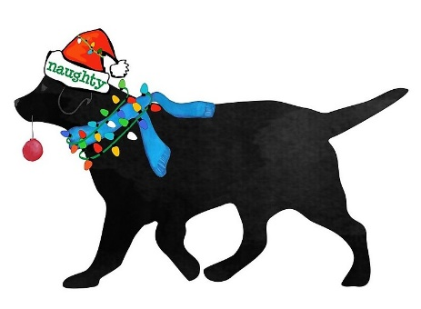
Dessert

Manger Christmas Pudding, brandy sauce
Bramley Apple and Mincemeat Crumble (vgn option)
Spiced Peach and Passionfruit Pavlova (vgn)
White Chocolate and Hazelnut Brownie
Death by Chocolate Cheesecake
Individual English and Continental Cheeseboard (v) (£3 supplement)
(served with either pouring cream, custard or ice-cream)
(with respect a £5pp deposit will be required at the time of booking)

